EECS6895 Final Project Report: A-share Stock AI Trader

Yiwen Fang  Fu Foundation School of Engineering and Applied Science, Columbia University  500 W 120th St., Mudd 510, New York, NY 10027  yf2560@columbia.edu | Guoshiwen Han  Fu Foundation School of Engineering and Applied Science, Columbia University  500 W 120th St., Mudd 510, New York, NY 10027  gh2567@columbia.edu

Abstract

The financial market is one of the first to adopt machine learning. Since the 1980s, people have been using machine learning to discover the laws of the financial market. Although machine learning has achieved great success in forecasting in other fields, the stock market is a market where everyone can invest in profit, but machine learning forecasts have not achieved significant results. As stock traders, we want to simulate stock prices or its trend correctly so that we can reasonably decide when to buy stocks and when to sell stocks in order to achieve maximum profitability. In this project, we will deploy LSTM, SVM, ARIMA methods to train models, then predict stock values or its trends. According to the result, we will design an algorithm to buy it at a low price, sell it at a high price, to achieve profits as much as possible. Finally, we will build a web application visualizing the result, which makes it more intuitive and easier to use and to accept for users.

Introduction
Traditional stock trading by manual analysis and operations can’t catch up with the current trend of the explosion of big data. The A-share stock market has 2,000 to 4,000 stocks with the historical trading data of half-century. It is important to have some methods to handle the big data; therefore, advancing and promoting the current trading techniques. Could a stock trend prediction and suggested operation be provided to the traders based on the historical data, with the help of the fast development of big data, artificial intelligence (AI), and machine learning (ML) techniques?
In this project, the approach started from a data pipeline, with data collection, cleaning, and pre-processing. Then, there machine learning models, i.e., long short-term memory (LSTM) [1][2][3], support vector machine (SVM) [4][5], autoregressive integrated moving average (ARIMA) [6][7][8], were investigated and developed. These three standalone models, as well as the integration model of the three models, were used to predict the future stock price and provide trading suggestions, e.g., buy, hold, sell. The experiments were provided to evaluate the performance of the trading methods, models, and algorithms. A Django web application framework [9] was used to assemble the machine learning modules, backend control, and frontend data valuations. Finally, the whole web application was deployed to the cloud platform AWS EC2 to be accessed over the world. Additionally, auto-updating scripts were used to keep datasets and models up to date.
Also, multiprocessing was used to reducing the model training time by parallel computing.
A completed web application is now working on the cloud. Users can add any specific stock, train a model, get real-time stock market data and immediate/fast-updated trading suggestions of over 2,000 stocks. The whole system has been refined to be a highly scalable, fast-running, and fast-updating AI trader.

Related work
Chen et al. [3] modeled and predicted China stock returns using LSTM. The historical data of China stock market was transformed into 30-days-long sequences with ten learning features and 3-day earning rate labeling. The model was fitted by training on 900,000 sequences and tested using the other 311361 sequences. Compared with the random prediction method, their LSTM model improved the accuracy of stock returns prediction from 14.3% to 27.2%. Their efforts demonstrated the power of LSTM in stock market prediction in China, which is mechanical yet much more unpredictable.
Lin et al. [4] proposed an SVM-based approach for stock market trend prediction. The proposed approach consisted of two parts: feature selection and prediction model. In the feature selection part, a correlation-based SVM ﬁlter was applied to rank and select a good subset of ﬁnancial indexes. And the stock indicators were evaluated based on the ranking. In the prediction model part, a so-called quasi-linear SVM was applied to predict stock market movement direction in term of historical data series by using the selected subset of ﬁnancial indexes as the weighted inputs.
Jarrett and Kyper [6] demonstrated the usefulness of ARIMA-Intervention time series analysis as both an analytical and forecast tool. The forecasting analysis indicated the usefulness of the developed model in explaining the rapid decline in the values of the price index of Shanghai A shares during the world economic debacle stating in China in 2008. Explanation of the fit of the model was described using the latest development in statistical validation methods. They inferred that the daily stock price index contains an autoregressive component; hence, one could predict stock returns.
The previous works solved the problem of stock predictions. Our approach is similar to the algorithms described above. However, the difference is that we use three models to vote and add suggested operations. The benefit is that they used the models/algorithms in an appropriate way, as well as the reasonable data pro-process. Unfortunately, the drawback is that they only considered one method for the stock prediction, thus resulting in some limitations. Instead, we take three methods together to judge stocks in this project.

Data

Data pipeline overview
The data source is the daily open-high-low-close (OHLC) time series price data of A-share main board stock in Shanghai Stock Exchange and Shenzhen Stock Exchange. The data volume is over 2,000 stocks, and each stock has daily data points lasting since IPO. The data is extracted and downloaded from Yahoo Finance by using the yahoo_fin API [14]. The data is cleaned by filtering out the NULL values for days that are closed for trading. Then the data will be pre-processed with different methods for training models. LSTM uses the absolute values of the prices. SVM uses the relations instead of absolute values. ARIMA uses resampling and difference.

Data pre-processing for training models
The LSTM model is trained by using the absolute values of the prices (Error: Reference source not found), then the prediction result is also format of absolute value.

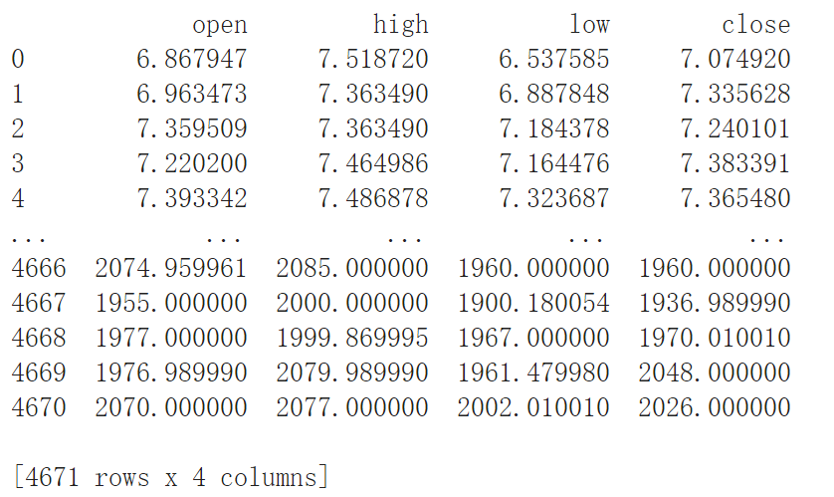
Figure 1: Pre-processing dataset for LSTM.

The SVM model is based on the relation between the prices. As you can see, now the data has six columns based on “open”, “close”, “high”, and “low”, which are absolute price values (Error: Reference source not found, Error: Reference source not found). Column “value”, which we will predict, is generated according to the difference between today’s closing price and the closing price of n days ago. If it is larger than 0, it means that today's price rises compared with n days ago; If it equals to 0, it means that today’s price doesn’t rise or fall compared with n days ago; If it is smaller than 0, it means that today's price falls compared with n days ago.

Figure 2: Dataset before pre-processing.

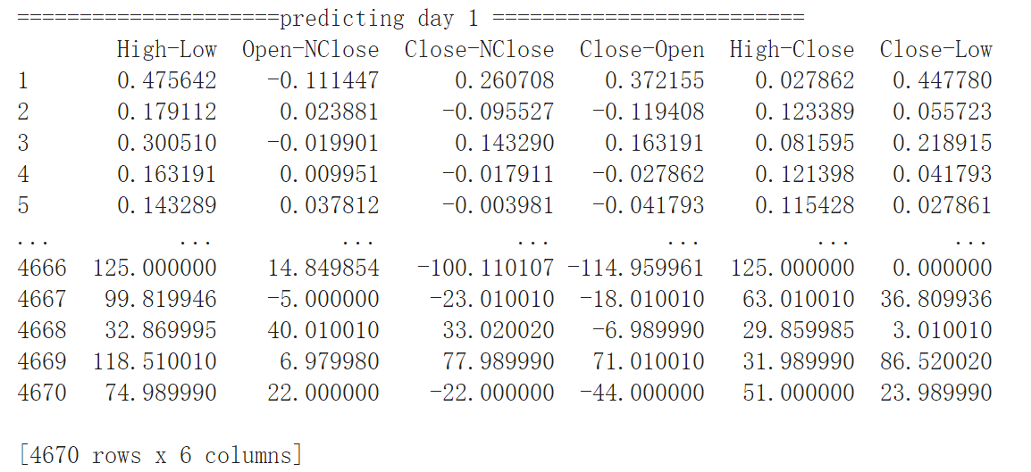
Figure 3: Dataset after pre-processing.

Now our goal transfers from predicting the price value of someday in the future to predicting the stock will rise or fall that day. Correspondingly, our prediction result only has three values: 1 means the stock will rise; -1 means the stock will fall; 0 means the price doesn’t change.
ARIMA requires to check the properties and characteristics of the data firstly, then according to them, choose reasonable parameters in training (Error: Reference source not found). Step 1 is to do resampling to determine the weekly average value (Error: Reference source not found). Step 2 is to do the first difference to the data (Error: Reference source not found). Step 3 is to check if ACF (Error: Reference source not found) and PACF convergent (Error: Reference source not found) and determine parameters q and p in training.

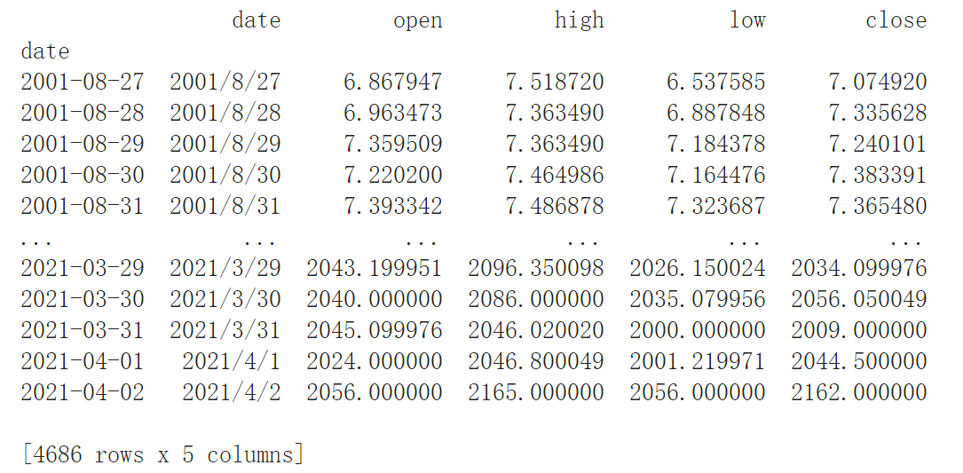
Figure 4: Dataset for ARIMA illustrating key parameters.

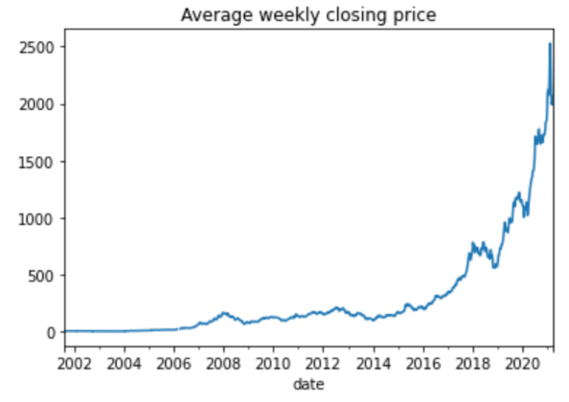
Figure 5: Graph of weekly average value by resampling.

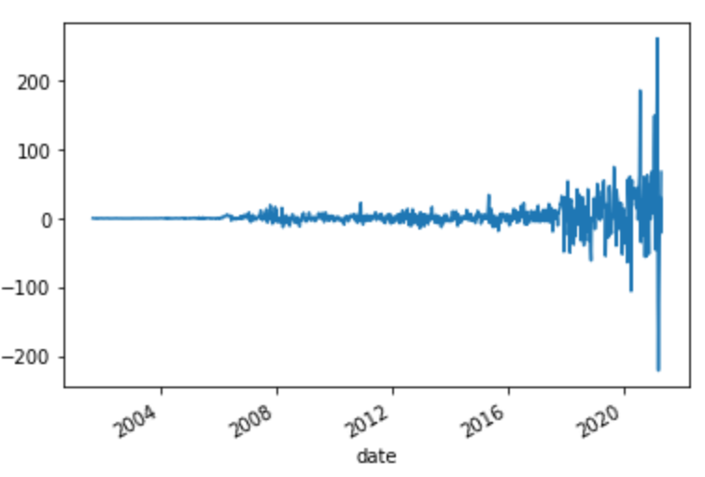
Figure 6: Graph illustrating data difference.

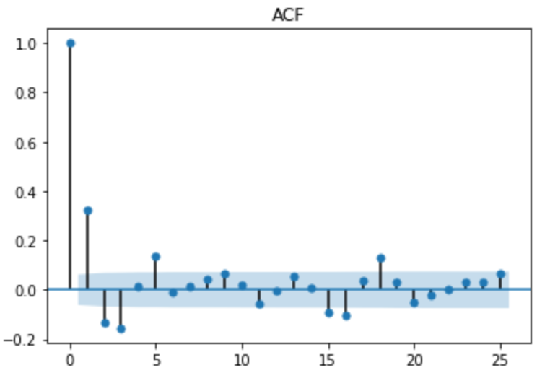
Figure 7: Graph to check if ACF convergent.

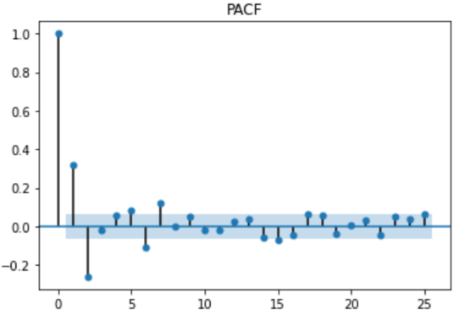
Figure 8: Graph to check if PACF convergent.

Methods
Based on the pre-processed datasets, three standalone models, i.e., SLTM, SVM, ARIMA, are implemented for training and predictions. The interesting part is that the integration of three models by voting the results is also implemented for predictions.

LSTM
Overlength papers will simply not be reviewed. This includes papers where the margins and formatting are deemed to have been significantly altered from those laid down by this style guide. Note that this LATEX guide already sets figure captions and references in a smaller font. The reason such papers will not be reviewed is that there is no provision for supervised revisions of manuscripts. The reviewing process cannot determine the suitability of the paper for presentation in eight pages if it is reviewed in eleven.
Long and short-term memory network models (Error: Reference source not found) are very powerful time series-based models that can predict any step backwards. An LSTM module (or an LSTM unit) uses five important parameters to model long-term and short-term data.

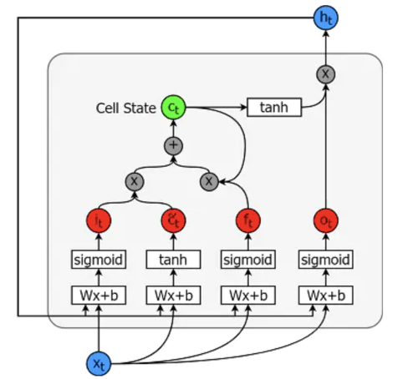
Figure 9: Schematic diagram of a LSTM model [10].

Unit state(c_{t}) represents the short-term and long-term memory of the unit storage. Hidden state(h_{t}) is the output state information calculated based on the current input, the previous hidden state, and the current unit input for predicting future stock prices. In addition, the hidden state also determines whether to use only the memory in the unit state (short-term, long-term or both) for the next prediction. Input gate(i_{t}) is where information flowing from the input gate to the unit state. Forgotten gate(f_{t}) is where information flows from the current input and the previous unit state to the current unit state. Output gate(o_{t}) is where information flows from the current unit state to the hidden state, which determines the type of memory that LSTM uses next.

SVM
SVM (Error: Reference source not found) has a natural anti-overfitting ability to remove outliers. The so-called support vectors are these data vectors that affect the hyperplane in the high-dimensional space. These data points are actually the points located on the “black solid line”, or the closest point to the dividing line. Under strong duality, the solution of the dual problem is the solution of the original problem, and the dual problem is always a Concave optimization problem, so the SVM solution must be a globally unique solution and will not fall into a local minimum.

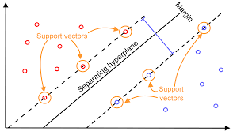
Figure 10: Schematic diagram of an SVM model [11].

The more commonly used kernel functions are the polynomial kernel function and Gaussian kernel function. Here in our project, we also choose a polynomial kernel function with 20 degrees.

ARIMA
The exponential smoothing method does not require the correlation between consecutive values in a time series. In some cases, we can create a better forecasting model by considering the correlation between the data. Among them, the autoregressive moving average model (ARIMA) is the most commonly used time series forecasting model. The time series model is usually suitable for short-term forecasting; that is, the past change pattern of the statistical series has not undergone fundamental changes.

Integration by three models’ voting
Three results are obtained through the above three models, and then we combine them into one final version by voting (Error: Reference source not found). If there are more than two models predicting that the stock will rise, then we take the majority and think the stock will rise; If there are more than two models predicting that the stock will fall, then we take the majority and think the stock will fall.

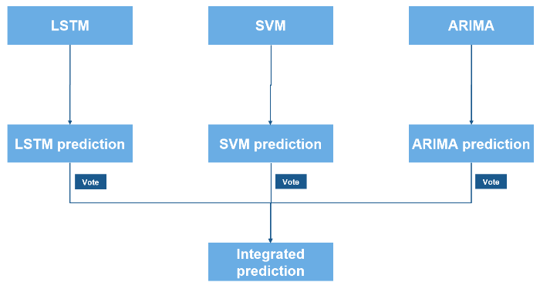
Figure 11: Integrated model by three models’ voting.

Experiments
The top 2 stocks are selected by market capitalization to do the experiments. And the data up to 5 days ago are used to predict the price trend of the last five days and the buying and selling operations that should be made. The operations are based on the results of the three models predicting the ups and downs: if most models predict that the stock will rise tomorrow, and a few models predict that the stock will fall tomorrow, then we believe that the stock will rise tomorrow.

Stock of Kweichow Moutai
Three solutions are given according to LSTM, SVM, ARIMA models. Then let three models vote to get the trend: If two or more models adjust that this stock will rise tomorrow, we choose to ignore the falling judgment and give out a reasonable trading strategy. Here we can see, the ideal operation should be: buy, hold, sell, hold, hold. However, none of our three models gives out a perfect matched solution; the accuracy of our model is hovering around 50%. (Error: Reference source not found, Error: Reference source not found)

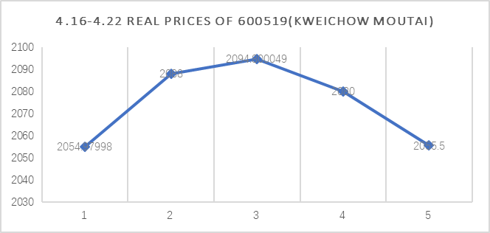
Figure 12: Real prices of Kweichow Moutai during 16 April - 22 April.

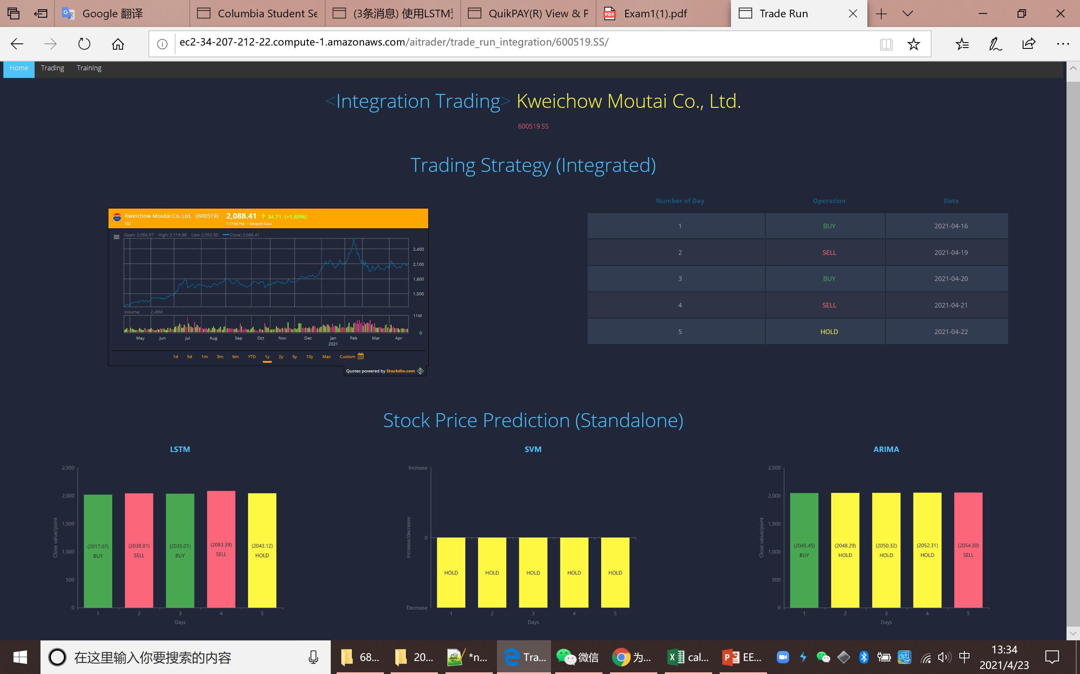
Figure 13: Predicted prices of Kweichow Moutai during 16 April - 22 April.

Based on our experimental results, SVM always performs a little bit better than the other two models. Although SVM does not achieve 100% accuracy and does not achieve the ideal profit maximization, we find that compared with the other two models, SVM rarely makes us lose money. (Table 1)

Model | 4/16 | 4/19 | 4/20 | 4/21 | 4/22
LSTM | buy | sell | buy | sell | hold
SVM | hold | hold | hold | hold | hold
ARIMA | buy | hold | hold | hold | sell
Integration | buy | sell | buy | sell | hold
Table 1: Trading operations predicted by different models.

Stock of ICBC
The conclusion we can get from this experiment of ICBC is very similar to Kweichow Moutai. SVM does not achieve 100% accuracy and does not achieve the ideal profit maximization, we find that comparing to the other two models, SVM rarely makes us lose money. (Error: Reference source not found, Error: Reference source not found)

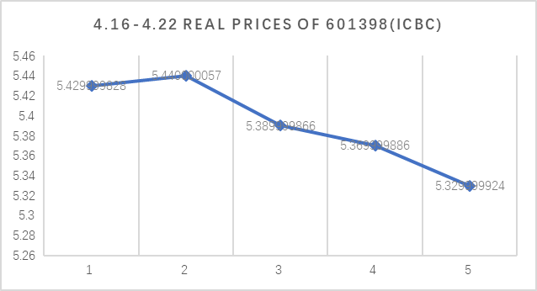
Figure 14: Real prices of ICBC during 16 April - 22 April.

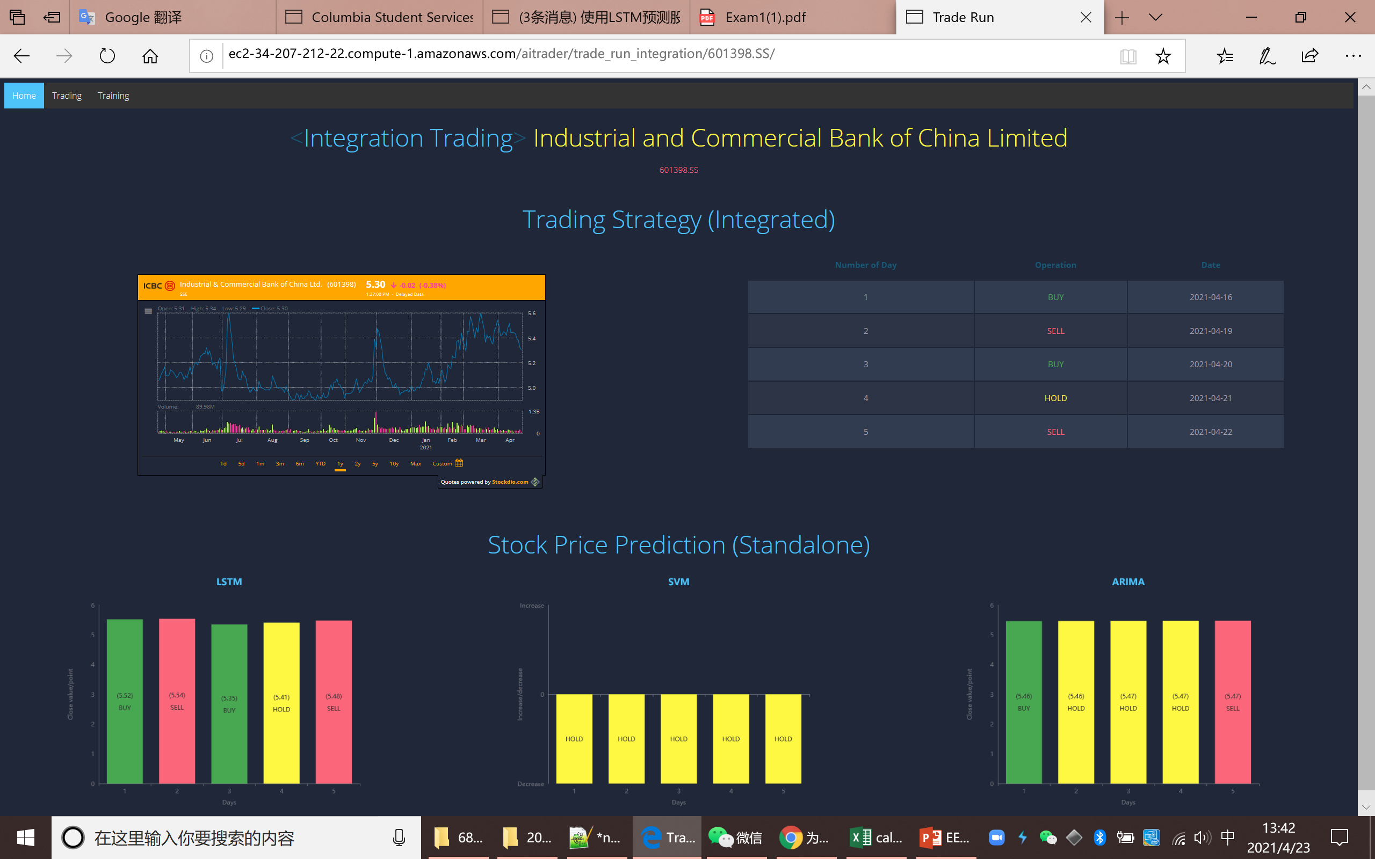
Figure 15: Predicted prices of ICBC during 16 April - 22 April.

System overview
The software architecture (Error: Reference source not found) consists of three main parts, i.e., machine learning models, backend, frontend. The machine learning models contain model training and predictions by using the libraries of TensorFlow, scikit-learn, and statsmodel. The backend is Python-based to handle MVC control, multiprocessing, data pipeline, and file system management. The frontend is the entry point for users implemented by HTML, CSS, JavaScript, and ECharts (a data visualization library) [13]. Both backend and frontend are the components of the Django web framework. The whole system can run on a local machine or be deployed to the cloud platform such as AWS EC2 in this project.

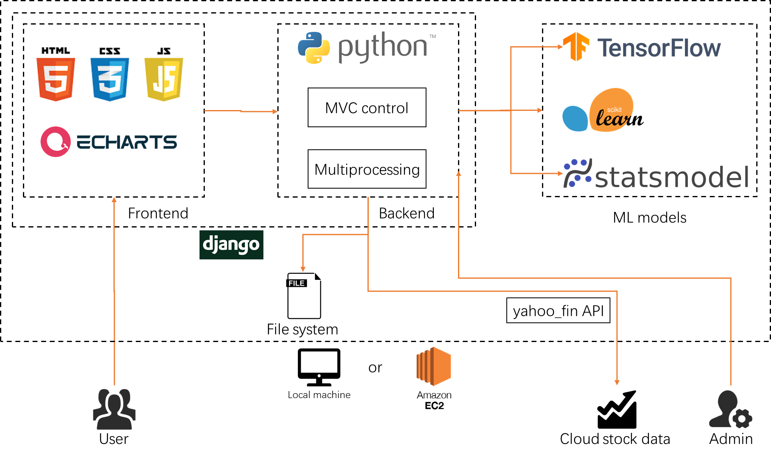
Figure 16: Schematic diagram of the system architecture.

User instruction
The landing page/entry point is the home page showing the real-time A-share market information (Error: Reference source not found) [12]. By clicking “Trading” in the menu, you can be directed to the trading page (Error: Reference source not found). For each stock, you can choose the method for trading and see the updated date. By clicking “Training” in the menu, you can be directed to the training page (Error: Reference source not found). For each stock, you can manually update daily stock datasets and retrain the models. You can also add new stocks. The trading pages of LSTM (Error: Reference source not found, Error: Reference source not found), SVM (Error: Reference source not found), ARIMA (Error: Reference source not found), and integration methods (Error: Reference source not found) can be showed by clicking the corresponding link on the “Trading” page. The vivid tables and graphs give clear trading indications to users.

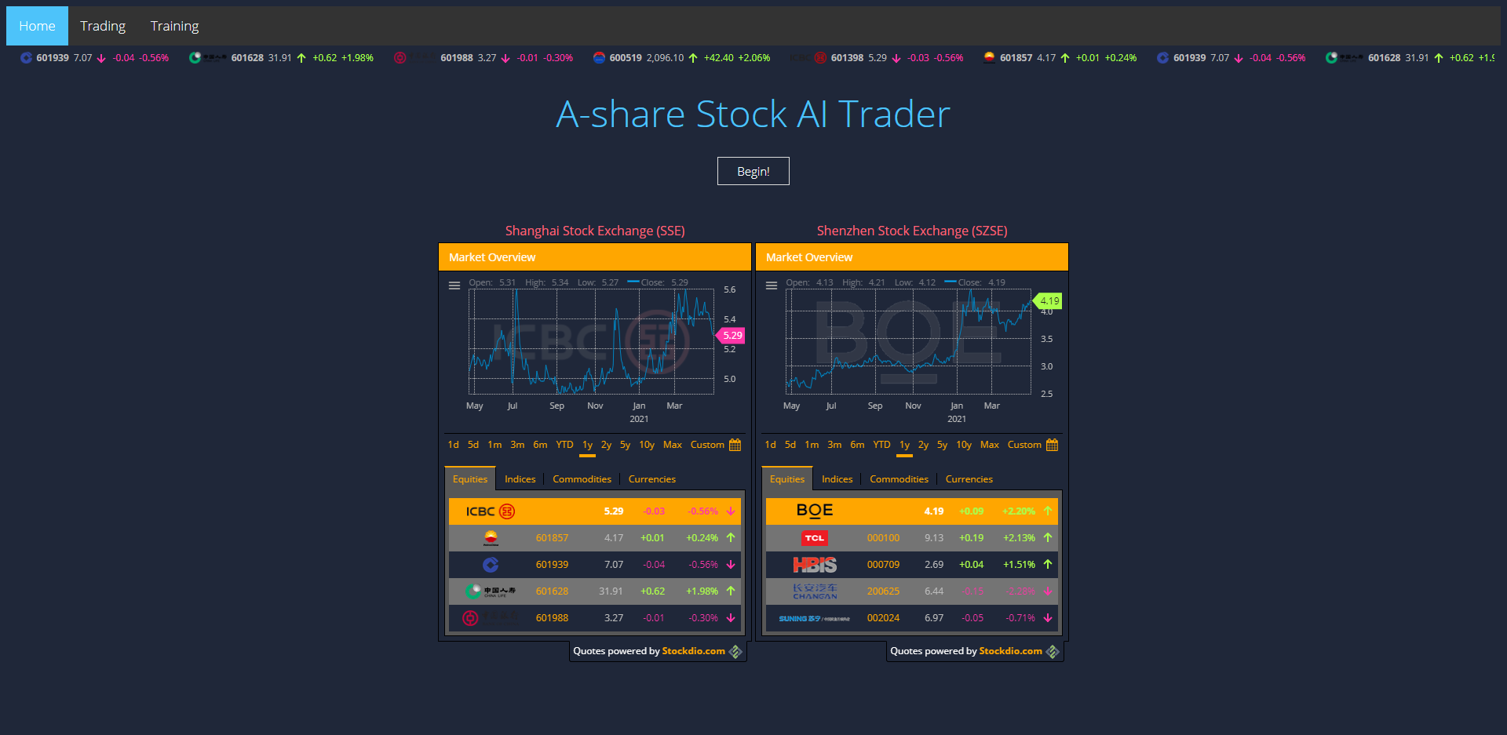
Figure 17: Application home page as the user entry point.

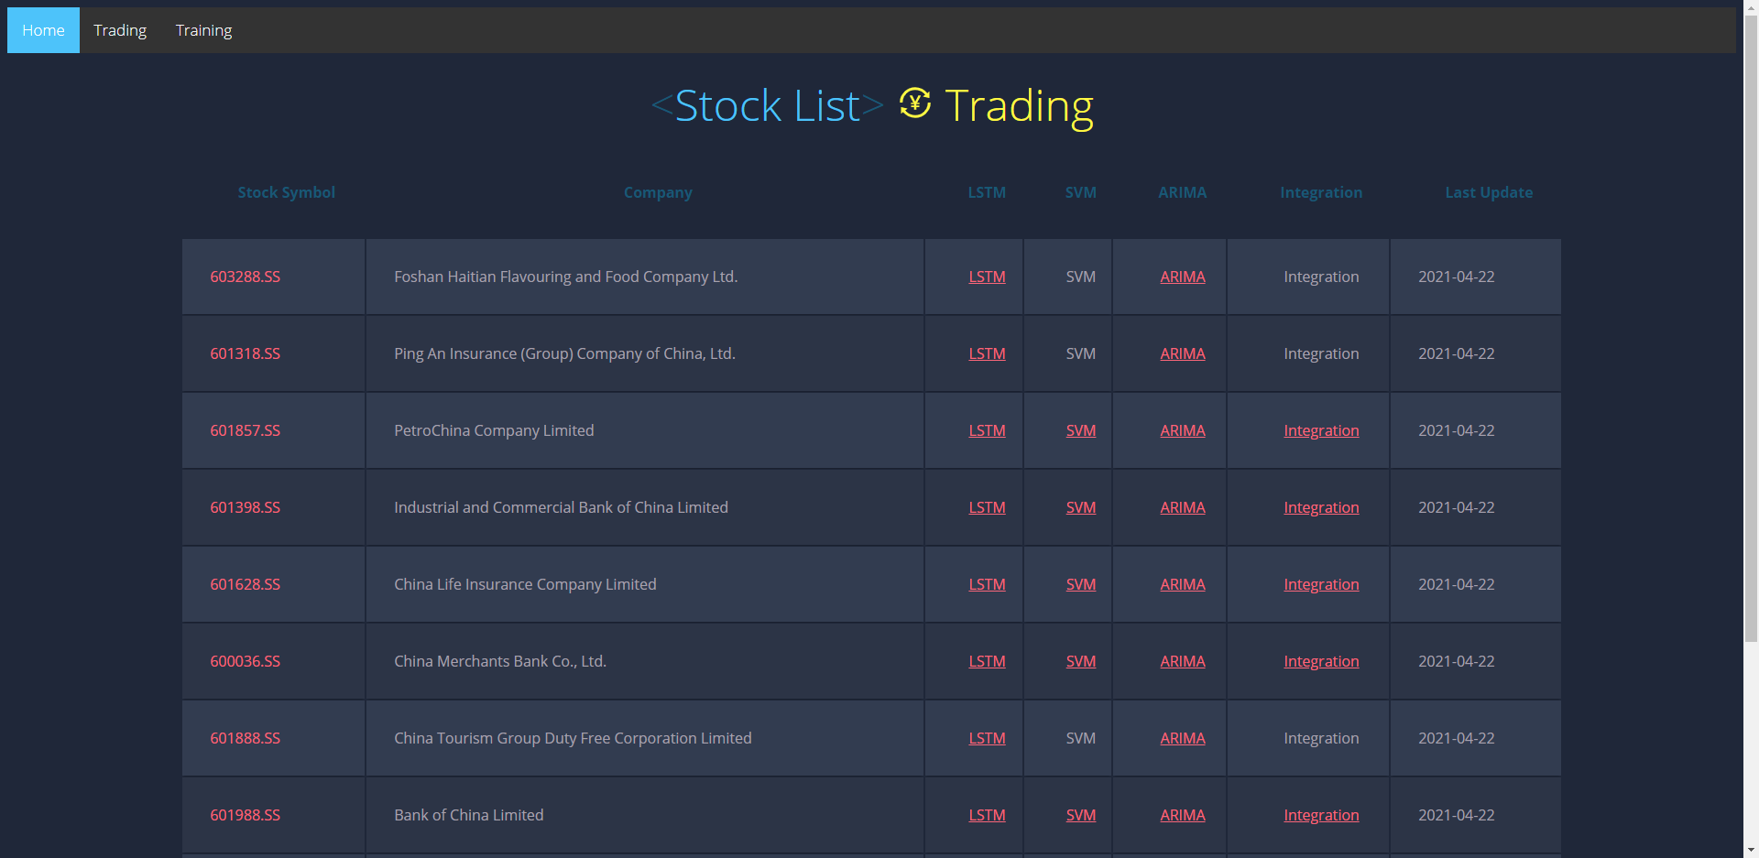
Figure 18: Application trading page showing stocks with various pre-trained models.

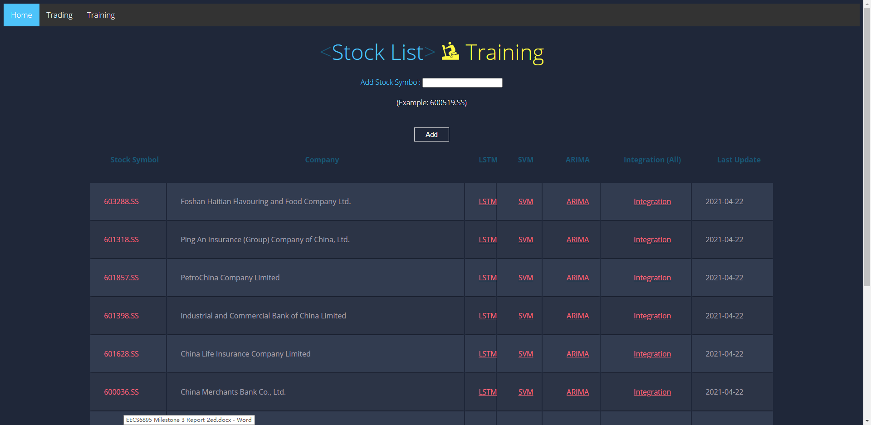
Figure 19: Application training page to add new stocks and manually updating existing models.

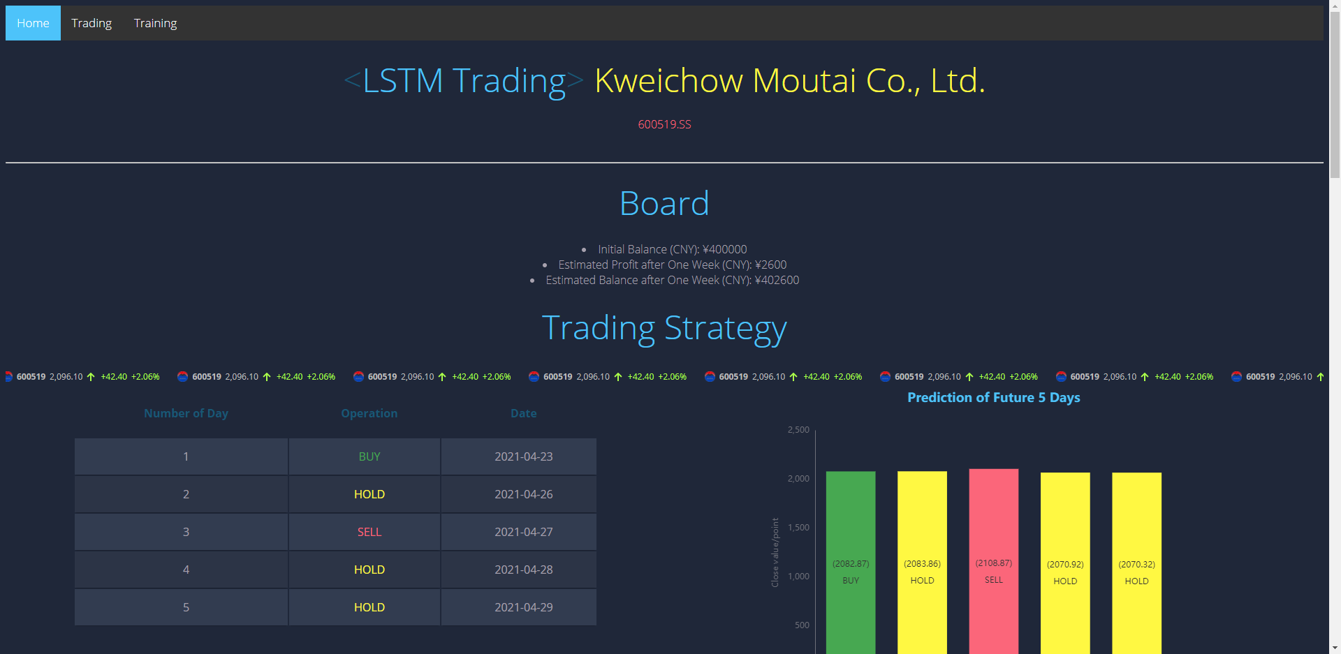
Figure 20: Application LSTM trading page showing the LSTM trading strategy.

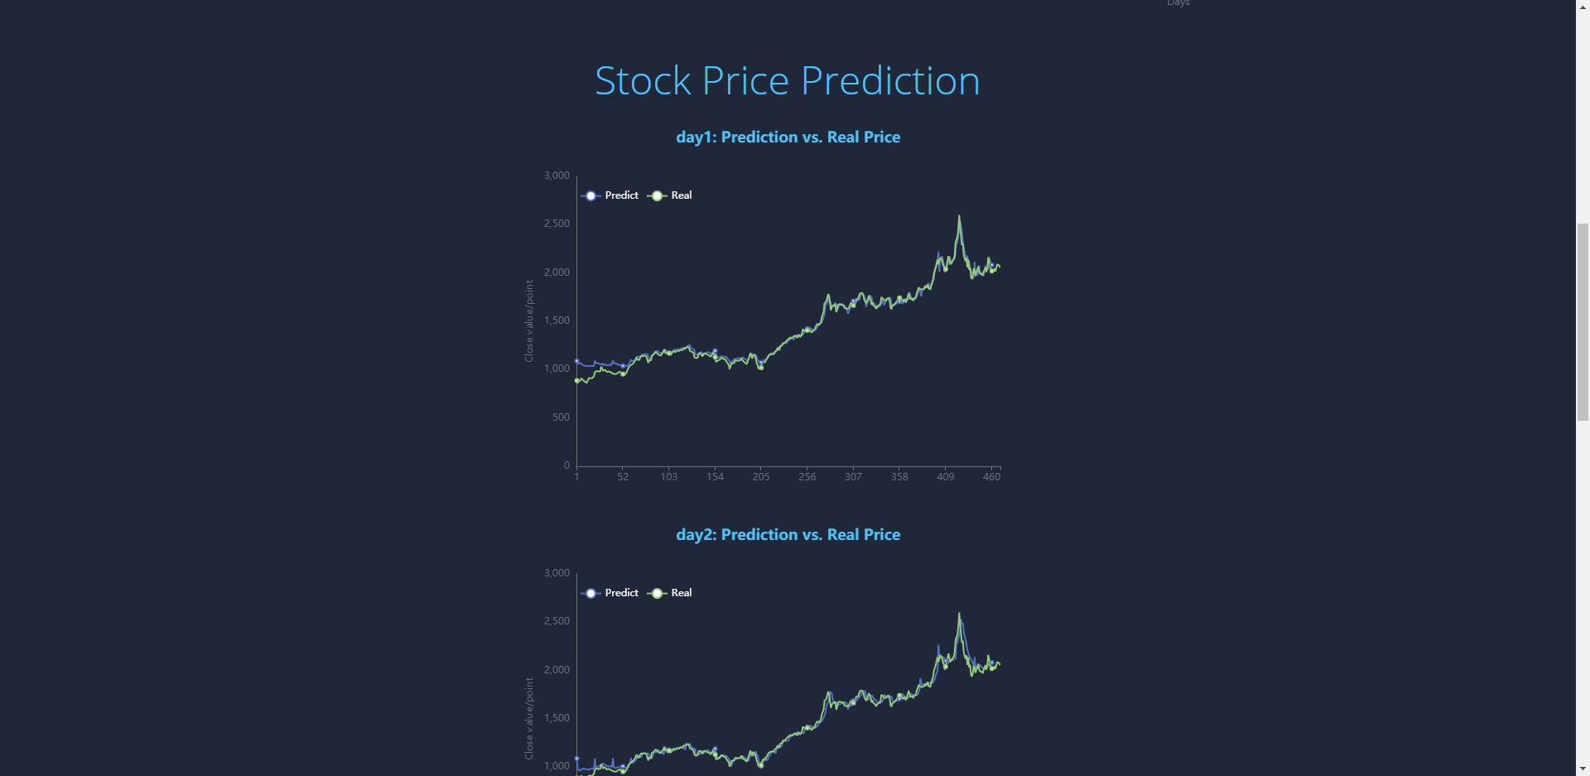
Figure 21: Application LSTM trading page showing LSTM predicted prices vs. real prices.

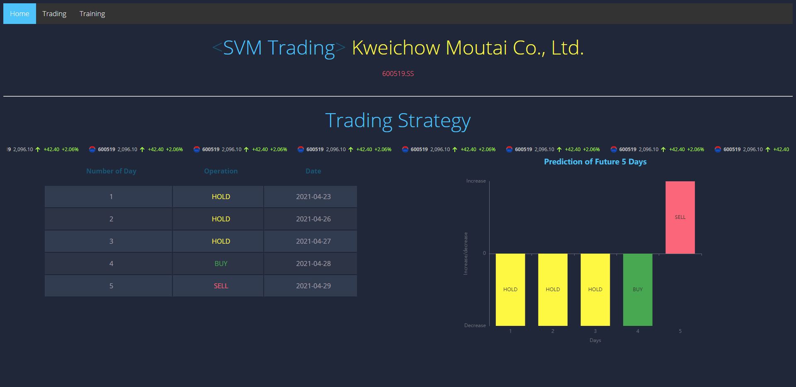
Figure 22: Application SVM trading page showing SVM trading strategy.

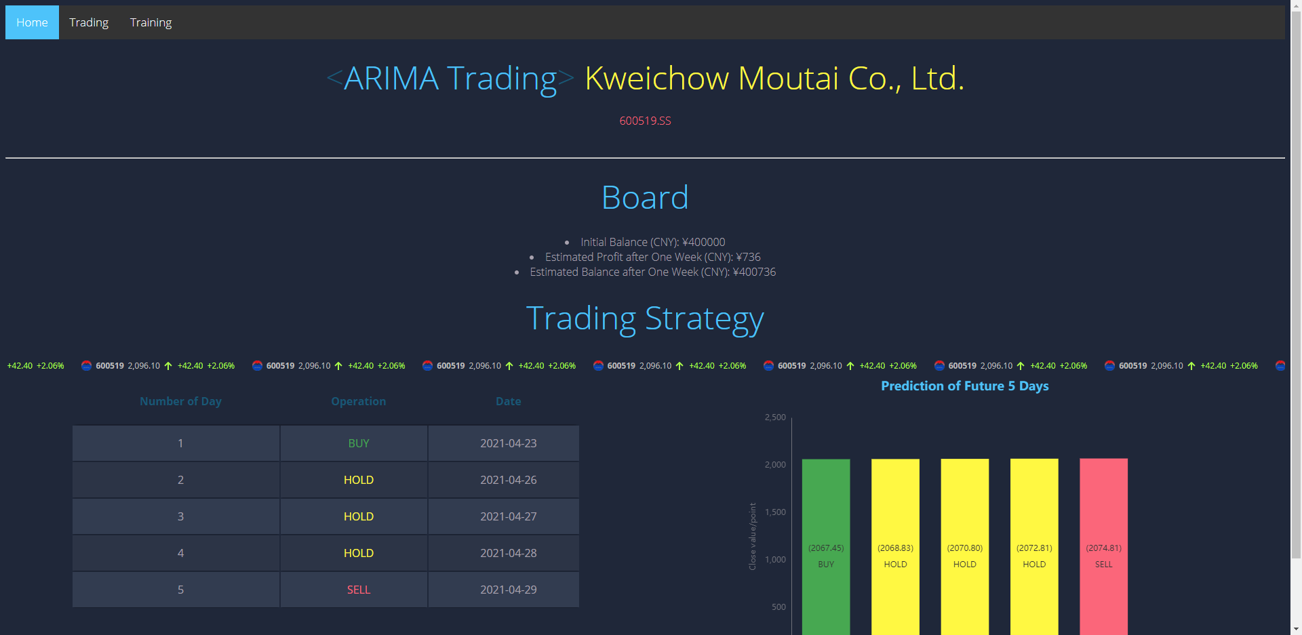
Figure 23: Application ARIMA trading page showing ARIMA trading strategy.

Figure 24: Application integration trading page showing the integrated trading strategy and three standalone predictions.

Challenges
The data volume for this project is over 2,000 stocks, with daily data points lasting since IPO for each stock. The data velocity is that the training time for each stock is about 10 minutes; therefore, training a number of stocks over the night is time-consuming. Multiprocessing is used to run parallelly, thus reducing the training time. The data variety faced is that LSTM, SVM, ARIMA, and the derived integration model co-exist to make predictions.
SVM may fail to make any predictions in some cases. The training of SVM shows that SVM may fail to be trained if all the values are 1 or -1, i.e., monotonic increasing/decreasing; SVM needs y to be at least two values. If this situation occurs, Increasing the training sample size can solve it.
The datasets and models require frequent update, such as once per day. Since stock trading data is updated every day, the data and the pre-trained models need to be updated frequently. Since we have thousands of stocks while each stock is associated with more than one model, an automatic updating script is used to do batch downloading and training tasks during a non-trading time, e.g., closing hour to opening hour.
A marvelous UI is a good way to improve the user experience. To replace the naive Matplotlib plots, a more powerful, interactive charting and visualization library called ECharts is used for data visualizations to make a more attractive website.

Further extensions
Currently, the machine learning modules are integrated with Django, and multiprocessing is used to fasten the model training process. However, the performance of multiprocessing highly depends on the number of cores in a CPU, in other words, the hardware of the local machine. To further speed up the process, the machine learning modules can be separated or detached from Django by deploying to independent machine learning hosting platform such as Amazon SageMaker to avoid the limitation of a single machine.
Three models, i.e., LSTM, SVM, ARIMA, are incorporated for the trading predictions. More additional models can be implemented to make standalone or integrated voting, thus giving a better performance. Also, the parameters of the input training datasets can be extended beyond the OHLC. More factor such as macroeconomic indicators and company financial report indicators can be used as the dimensions of the training input.

Conclusion
We have built up a web application to support the trading of the A-share stock market. The business values include but not limited to (1) trend prediction system of stock prices; (2) buy/hold/sell operating strategy for users; (3) integration of three machine learning algorithms for trading; (4) vivid visualization charts and real-time information.
We provide integrated trading decisions for users. Vivid visualization charts containing trading information are shown on the frontend. The functionalities of automatic dataset update/model retraining are implemented to ensure the predicted results up-to-date. The whole web application is running on the cloud platform; therefore, everyone over the world can get access to this AI trading service.
However, there are also some further thinking. From the current accuracy of our three models, SVM is better than LSTM than ARIMA. However, the errors of the three models are still very high. Even if we consider the prediction results of the three models, the accuracy rate is still slightly higher than 50%.
There are many factors that affect the rise and fall of a stock. In addition to the opening price, closing price, highest price, and lowest price visible in the financial market (the four factors we considered in our model), there are many factors that affect its trends, such as trading volume, price-earnings ratio, market value, internal and external disks, company acquisitions, bad or good news, and a lot of human factors. These unforeseen factors all affect the trend of stocks from many parties, and it is difficult for the ML model to collect all the information in all directions and train the prediction model.
As Princeton University economics professor Burton Malkiel wrote in his book "A Random Walk Down Wall Street" published in 1973: “If the stock market is efficient enough that people can know all the factors that affect it from public stock prices, then everyone can speculate in stocks like investment professionals.”

Supplementary materials
Deployed link: http://ec2-34-207-212-22.compute-1.amazonaws.com/aitrader/
GitHub repo and YouTube video: Refer to ID 202105-6 on https://www.ee.columbia.edu/~cylin/course/bigdata/projects/

Acknowledgements
We would like to thank all the authors in the references for the valuable pioneer work. Also, we would like to thank Professor Ching-Yung Lin and TA Hassan Akbari for the selfless help in the course.

References
- Chen, K., Zhou, Y. and Dai, F., 2015, October. A LSTM-based method for stock returns prediction: A case study of China stock market. In 2015 IEEE international conference on big data (big data) (pp. 2823-2824). IEEE.
- Roondiwala, M., Patel, H. and Varma, S., 2017. Predicting stock prices using LSTM. International Journal of Science and Research (IJSR), 6(4), pp.1754-1756.
- Nelson, D.M., Pereira, A.C. and de Oliveira, R.A., 2017, May. Stock market's price movement prediction with LSTM neural networks. In 2017 International joint conference on neural networks (IJCNN) (pp. 1419-1426). IEEE.
- Lin, Y., Guo, H. and Hu, J., 2013, August. An SVM-based approach for stock market trend prediction. In The 2013 international joint conference on neural networks (IJCNN) (pp. 1-7). IEEE.
- Huang, W., Nakamori, Y. and Wang, S.Y., 2005. Forecasting stock market movement direction with support vector machine. Computers & operations research, 32(10), pp.2513-2522.
- Jarrett, J.E. and Kyper, E., 2011. ARIMA modeling with intervention to forecast and analyze Chinese stock prices. International Journal of Engineering Business Management, 3(3), pp.53-58.
- Ariyo, A.A., Adewumi, A.O. and Ayo, C.K., 2014, March. Stock price prediction using the ARIMA model. In 2014 UKSim-AMSS 16th International Conference on Computer Modelling and Simulation (pp. 106-112). IEEE.
- Banerjee, D., 2014, January. Forecasting of Indian stock market using time-series ARIMA model. In 2014 2nd International Conference on Business and Information Management (ICBIM) (pp. 131-135). IEEE.
- https://docs.djangoproject.com/en/3.2/
- https://blog.nowcoder.net/n/9e75cb640cb24582b6f492fb7d895d99
- https://static.packt-cdn.com/products/9781789345070/graphics/6a831600-9a0d-429f-9d34-d957c45b9517.png
- https://services.stockdio.com/howtouse
- https://echarts.apache.org/en/index.html
- https://pypi.org/project/yahoo-fin/

